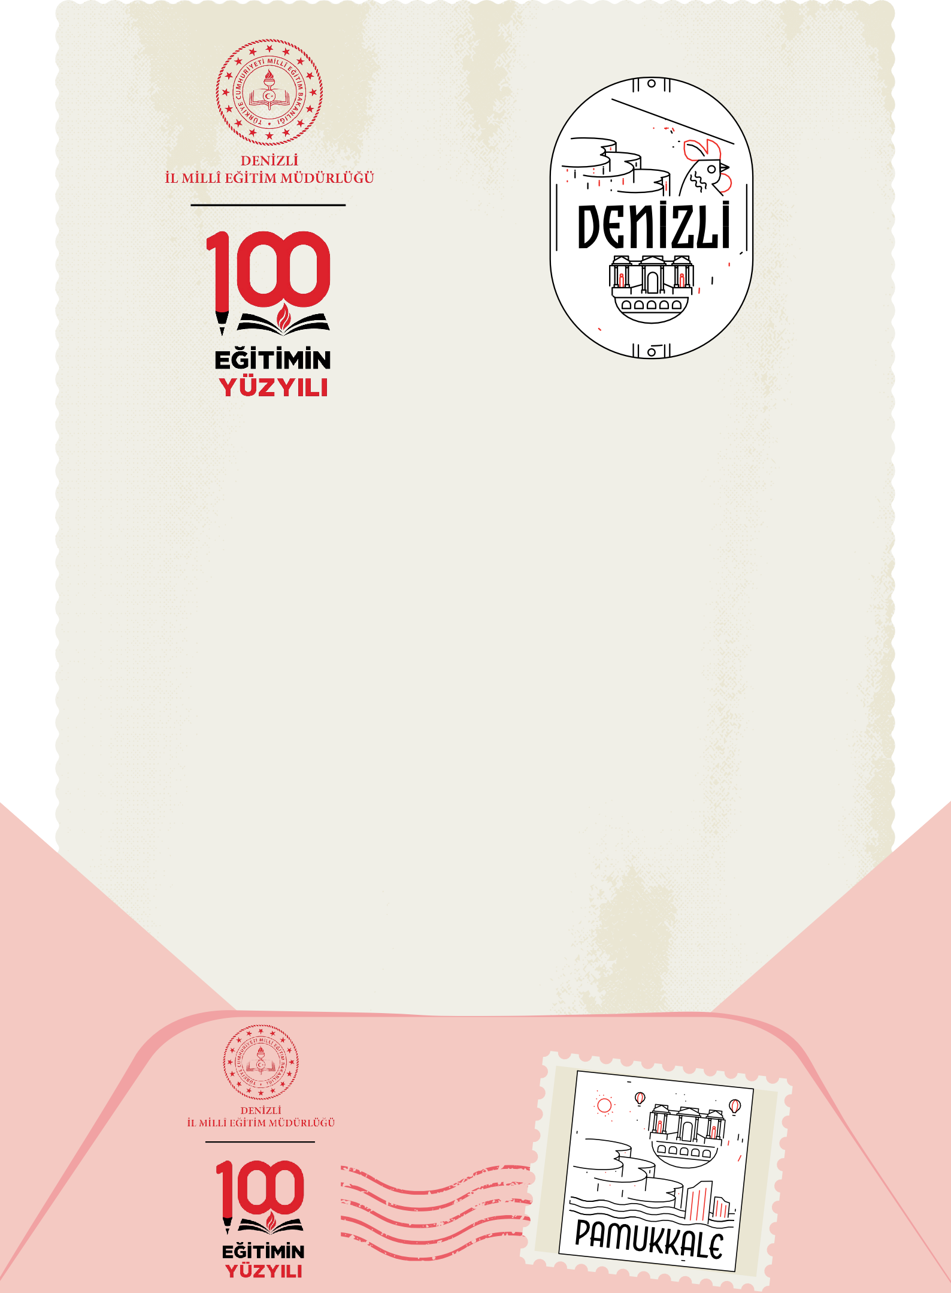**EK**

**KÜLTÜR DURAĞINDA**

**DENİZLİ İL MİLLÎ EĞİTİM MÜDÜRLÜĞÜ**

**“KÜLTÜR DURAĞINDA DENİZLİ”**

**İYİ UYGULAMALAR ÇALIŞMASI**

**...............**

**AYI BÜLTENİ**

2024-2025

**KÜLTÜR DURAĞINDA**

DENİZLİ İL MİLLÎ EĞİTİM MÜDÜRLÜĞÜ

. İLOKULU/ORTAOKULU

AYLIK YAPILAN ÇALIŞMALAR İLE İLGİLİ AÇIKLAYICI METİN

**..................................................................................................**

**..................................................................................................**

**..................................................................................................**

**..................................................................................................**

**..................................................................................................**

**..................................................................................................**

**..................................................................................................**

**..................................................................................................**

**..................................................................................................**

**..................................................................................................**

**..................................................................................................**

**................................................**

06 Aralık 2024